Introduction to Bayesian Data Analysis

Homework 1

104502518資工4A劉冠聲

This homework assignment is due by midnight of 10/1. Please submit a hard copy of your homework to 工五館B322. 50% penalty will be applied if it is submitted on 10/2. No submission will be accepted after 10/2.

1. Consider Figure 2.6, p. 29, in textbook. Two of the data points fall above the vertical bars. Does this mean that the model does not describe the data well? Briefly explain your answer.

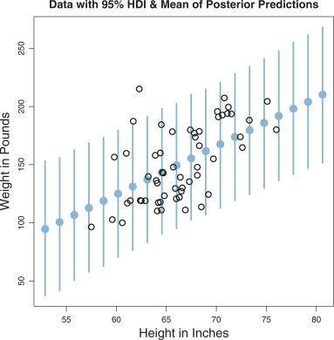

***ANS.***

否，此模型已足夠用來推論身高體重成長比的資料分布。

此模型由貝氏推論所得，在重複5個步驟後，可發現身高體重對應的資料分布已十分符合模型的線性趨勢，而體重的誤差範圍是由HDI所得，亦即有95%的資料在此模型範圍內，對於預測資料的身高體重已非常充足，若有在預測範圍外的資料，由於過於稀少，可視為例外資料，不須為此納入模型考量而過度設計。

1. 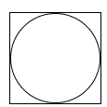Consider the following Figure, where a circle is inscribed in a square. If a large amount of points are randomly generated in the square, the ratio of the points in the circle to all the points should be π/4. Please write an R program to compute the value of π based on this idea. You can set the total number of points to be 103, 104, 105, and 106 to compute π, and draw a figure using the exponent of 10 as x value and the estimated π as y value.

***ANS.***

